EMAIL ALERTS BY USING PROMETHEUS &GRAFANA

* Go to AWS console
* Launch an ec2 instance by using ubuntu.

( instance type : t3 large , volume 30 gib)

* Connect to the instance and run the following commands
* **sudo su**
* **sudo apt update**
* Install docker by using following command.
* apt install docker.io
* **install Prometheus, Grafana and Jenkins by using docker by using below procedure**

**Installation of Prometheus:**

* make a Prometheus directory in /home/ubuntu

**mkdir /home/ubuntu/prometheus**

* configure the file by using following command

**nano /home/ubuntu/prometheus/prometheus.yml**

# my global config

global:

scrape_interval: 15s # By default, scrape targets every 15 seconds.

evaluation_interval: 15s # Evaluate rules every 15 seconds.

# scrape_timeout is set to the global default (10s).

# Alertmanager configuration

alerting:

alertmanagers:

- static_configs:

- targets:

# Alertmanager's address

#- localhost:9093

# Load alerting rules

rule_files:

# List your alert rules here

- "alert_rules.yml"

# A list of scrape configurations

scrape_configs:

# Scrape configuration for Prometheus itself

- job_name: 'prometheus'

static_configs:

- targets: ['localhost:9090']

# Example scrape config for a Node Exporter

- job_name: 'jenkins'

metrics_path: '/prometheus'

static_configs:

- targets: ['localhost:8080'] # Node Exporter on localhost

* Mention the above configuration in the Prometheus.yml and replace the localhost with public IP

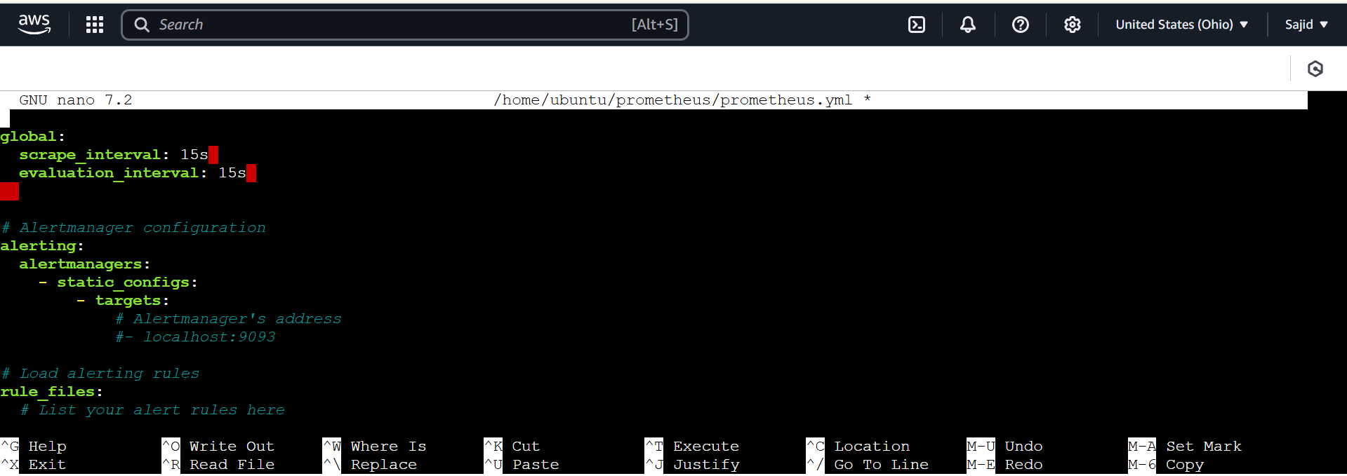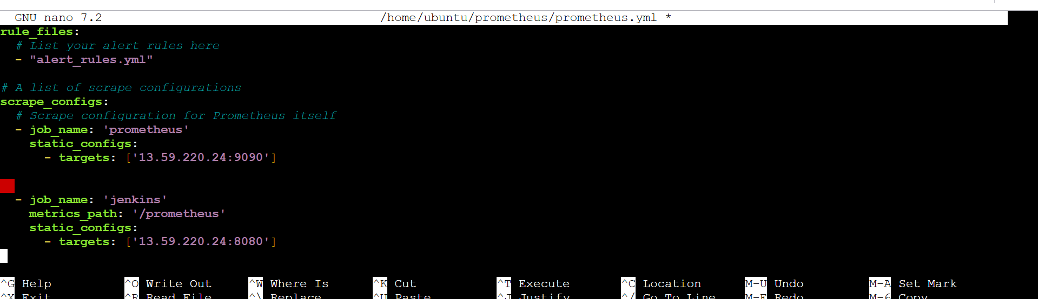

* Save the file using ctrl+X, ctrl+Y and press enter
* Now install the Prometheus by using docker command

**docker run -d --name prometheus-container -v /home/ubuntu/prometheus/prometheus.yml:/etc/prometheus/prometheus.yml -e TZ=UTC -p 9090:9090 ubuntu/prometheus:2.33-22.04_beta**

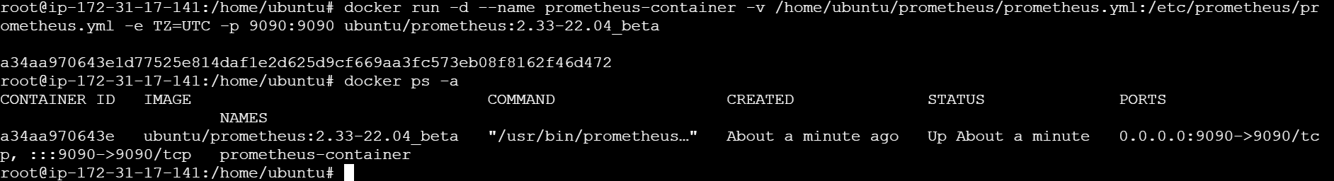

**INSTALLATION OF GRAFANA:**

* Make a Grafana directory by using following command

**mkdir /home/ubuntu/grafana**

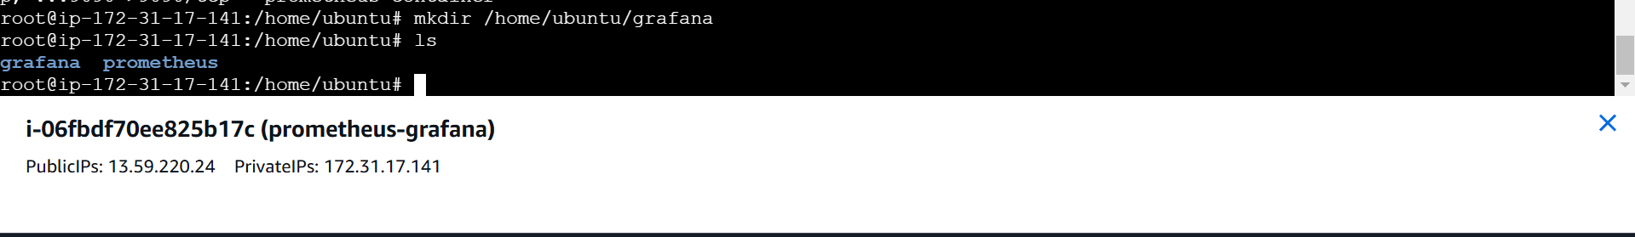

* Configure the file by using following command

**nano /home/ubuntu/grafana/grafana.ini**

[smtp]

enabled = true

host = smtp.gmail.com:587

user = example@gmail.com

password = <new-password-or-app-password> ( Google account app password)

from_address = example@gmail.com

skip verify = true

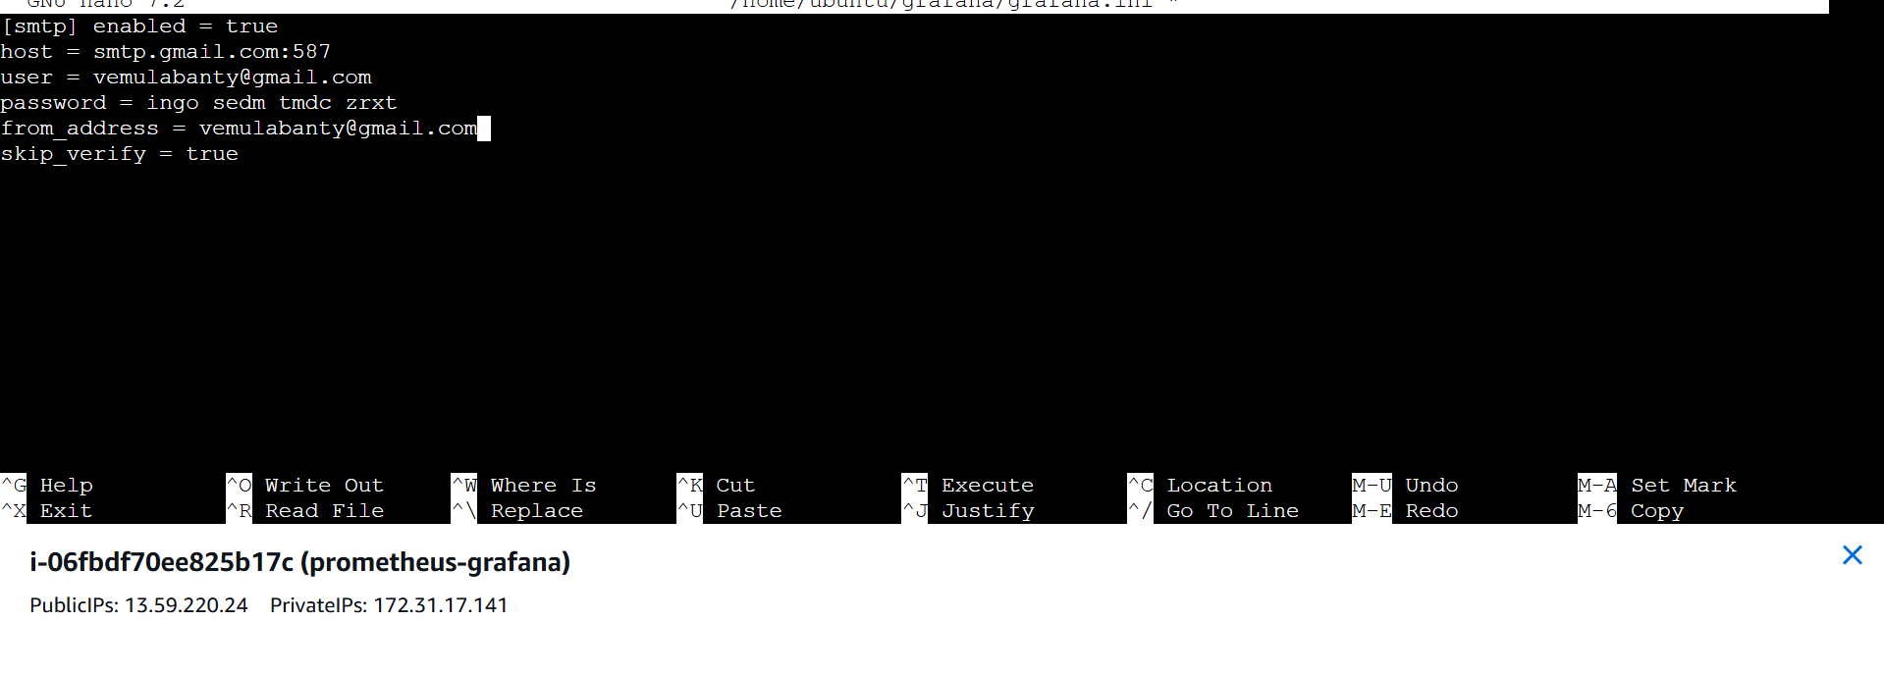

* Save the file using ctrl+X, ctrl+Y and press enter.
* Now install the Grafana by using docker command

docker run -d --name=grafana -p 3000:3000 -v /home/ubuntu/grafana/grafana.ini:/etc/grafana/grafana.ini grafana/grafana:8.5.5

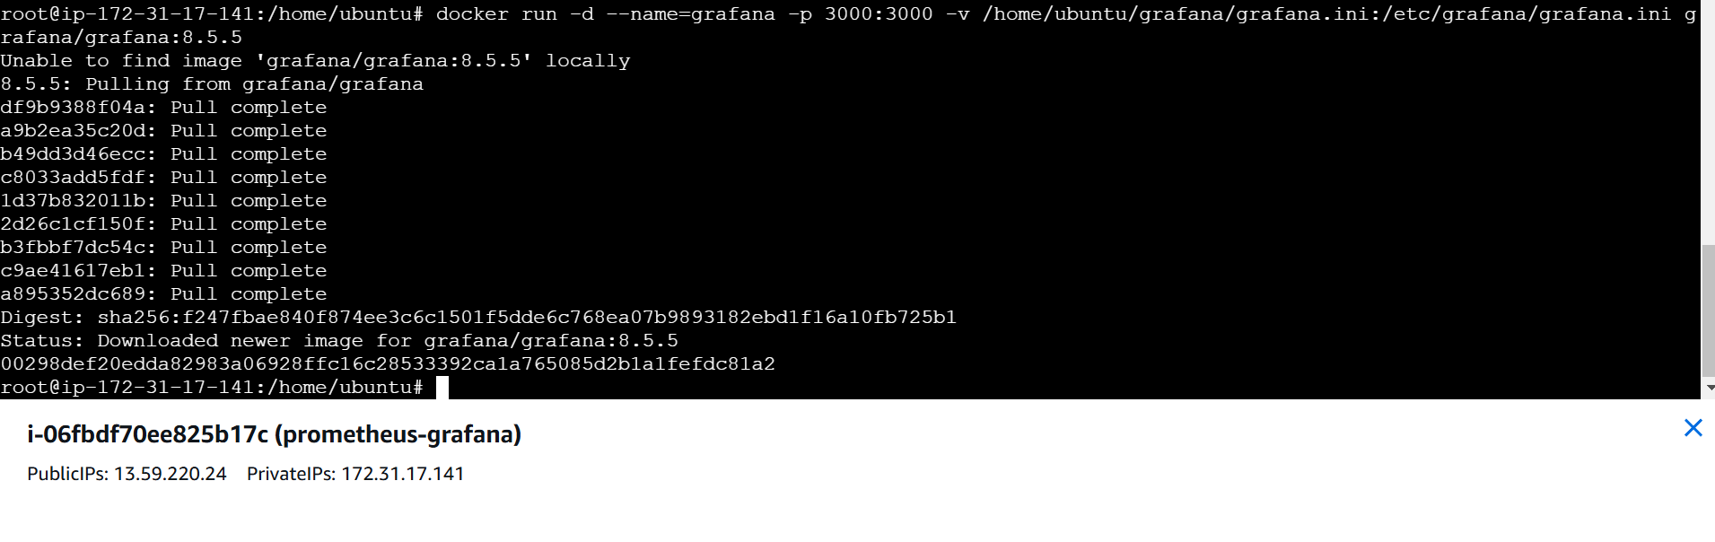

**INSTALLATION OF JENKINS:**

* **Now install Jenkins by using following command**

docker run -d -p 8080:8080 jenkins/jenkins:lts-jdk11

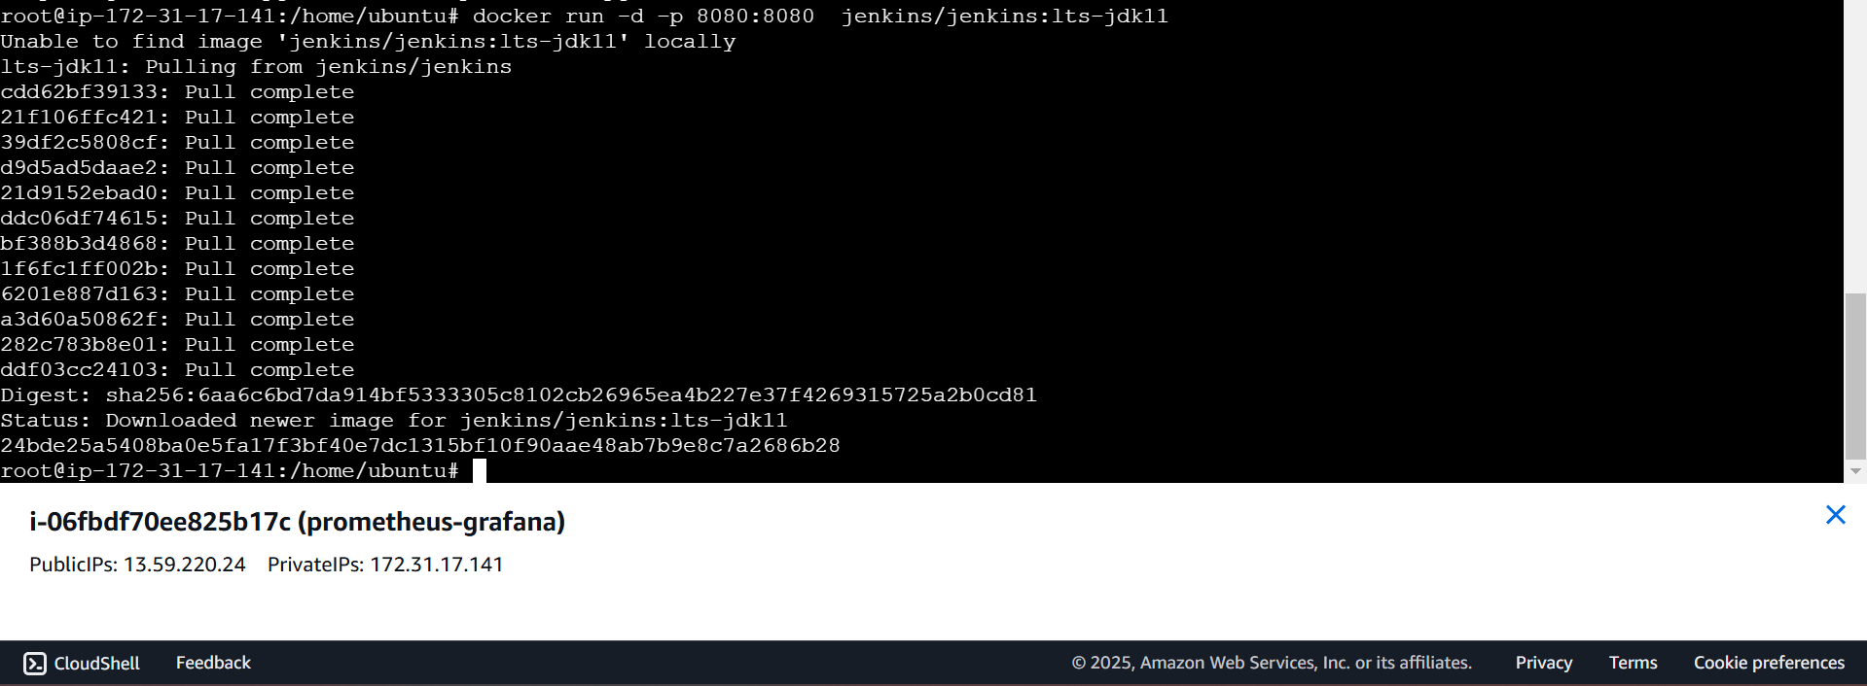

* **Add the port numbers in Security groups**
* **Add the security groups:**

9090 (Grafana)

8080 (Jenkins)

3000 (Prometheus)

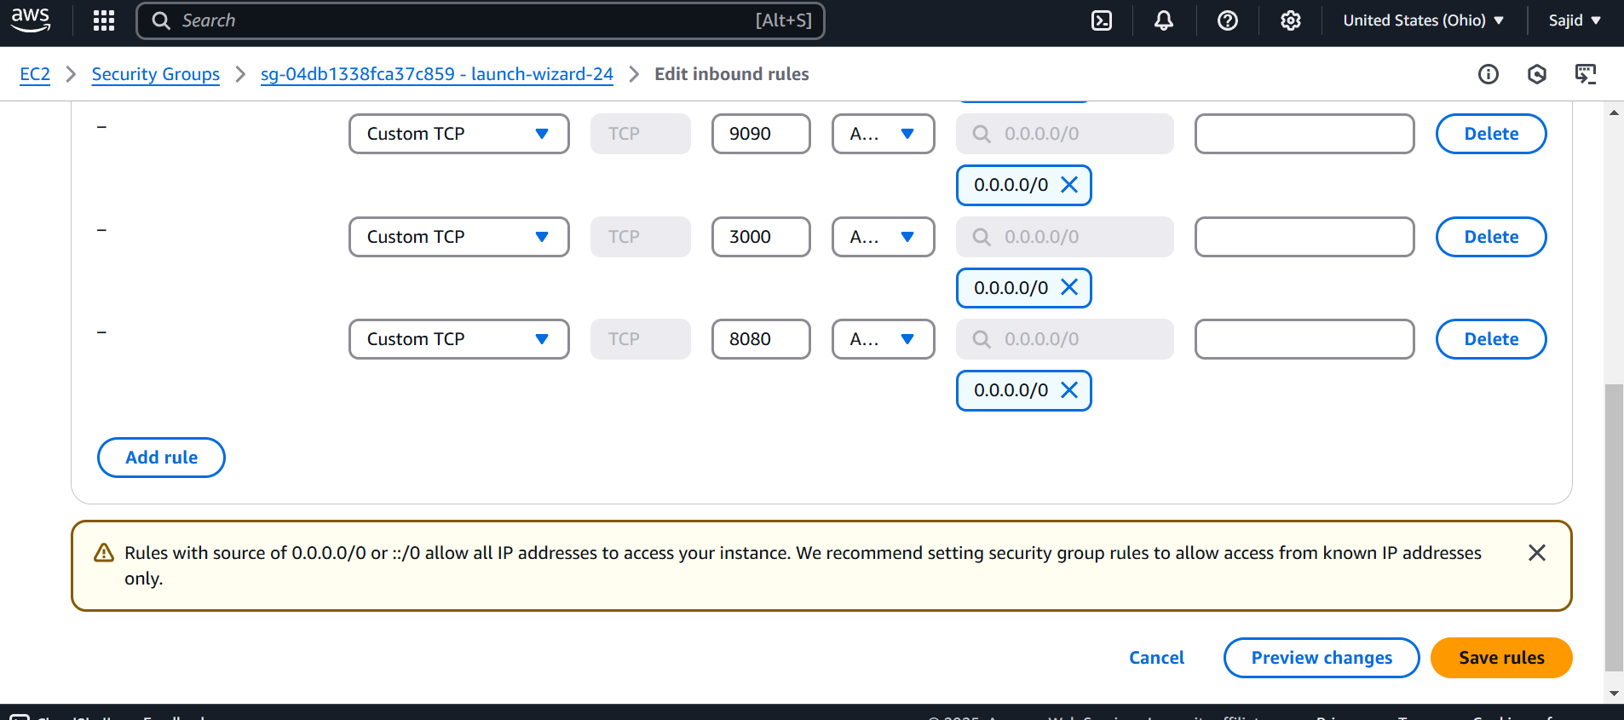

* **Connect to the Grafana, Prometheus, and Jenkins.**
* Start the Containers of Grafana, Prometheus and Jenkins by using following command.

**docker start (Jenkins container ID)**

**docker start (Grafana container ID)**

**docker start (Prometheus container ID)**

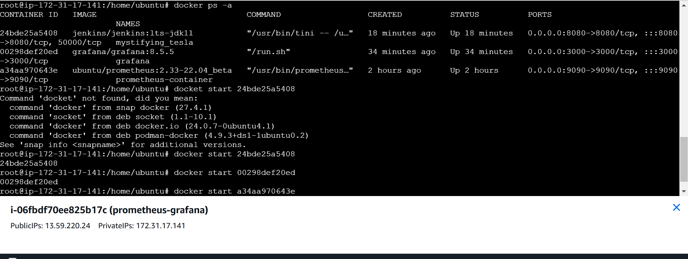

* **Now connect to the servers by using IP**
* **Server IP & port Number -**13.59.220.24:8080 (For Jenkins)
* **For Jenkins password we run the following command in server**

docker exec < jenkins cont ID> cat /var/jenkins_home/secrets/initialAdminPassword

* After getting into Jenkins dashboard.
* Click on “**Manage Jenkins”**
* Click on **“Plugins”**
* Click on “**Available Plugins”** and install Prometheus metrics & Click on install.

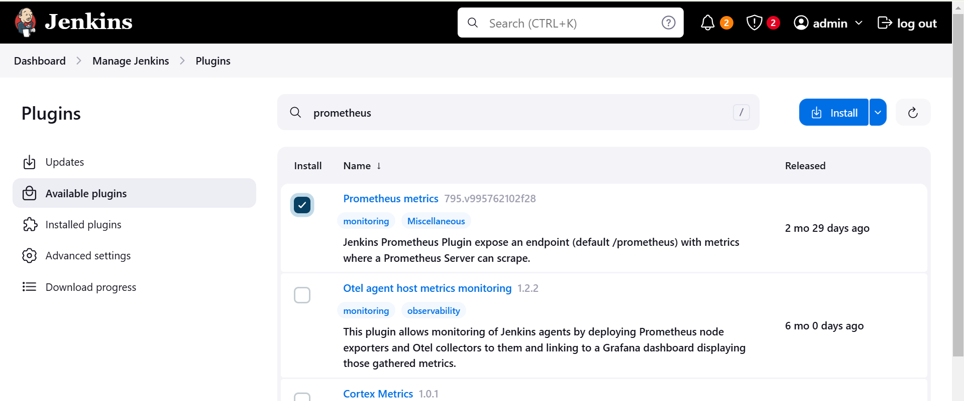

* Now restart the Jenkins

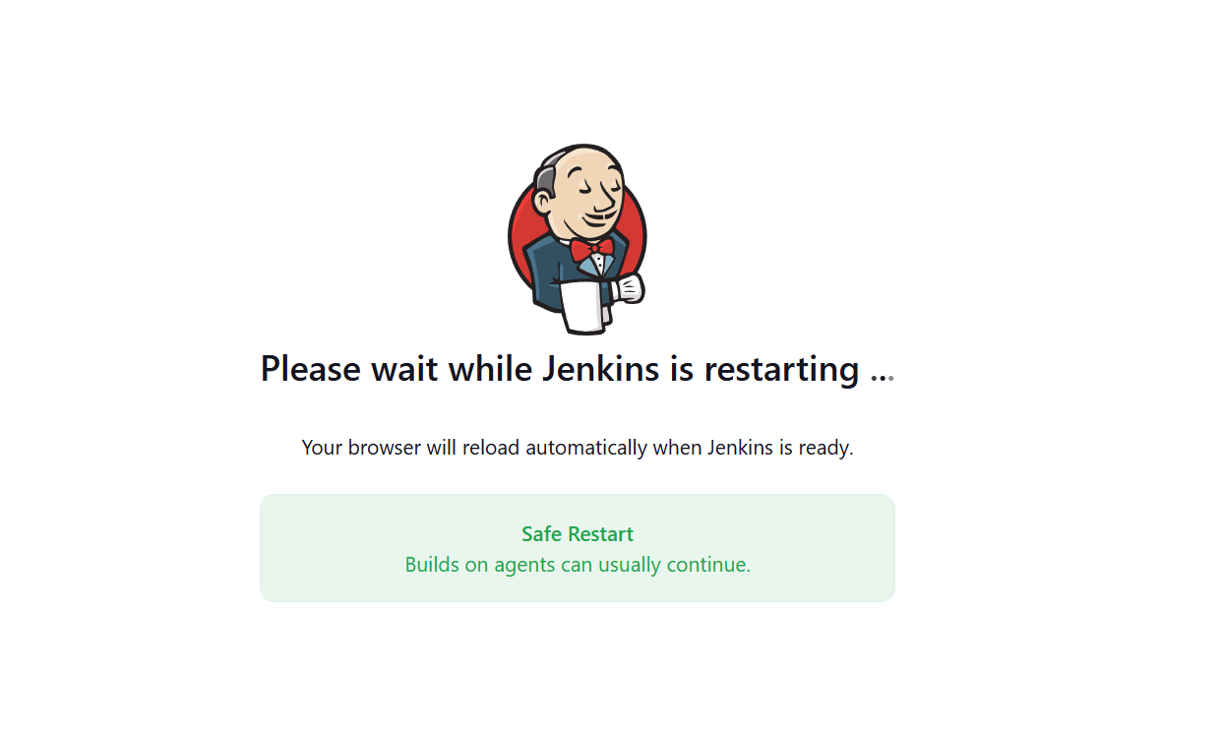

* **Server IP & port Number-** 13.59.220.24:9090 (For Prometheus)

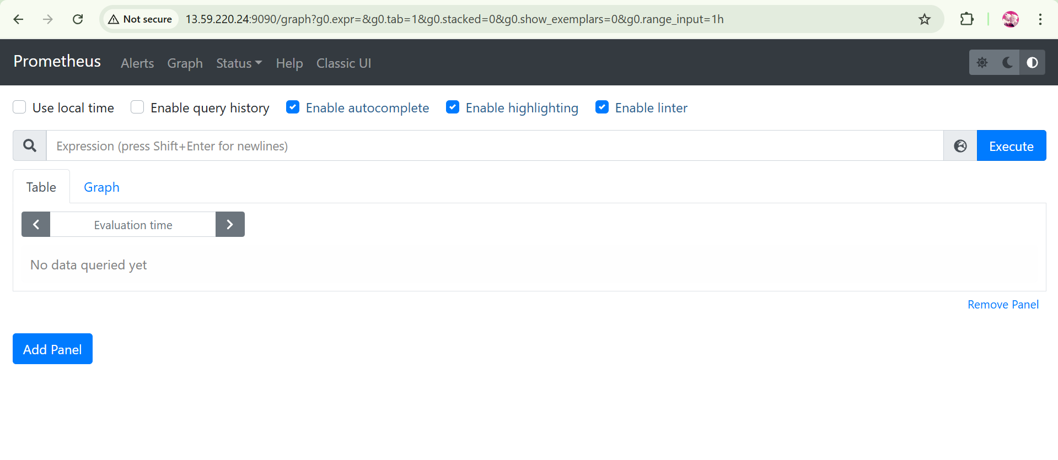

* Refresh the Prometheus page.
* Click on status and then click on targets
* It will show the status of Jenkins and Prometheus

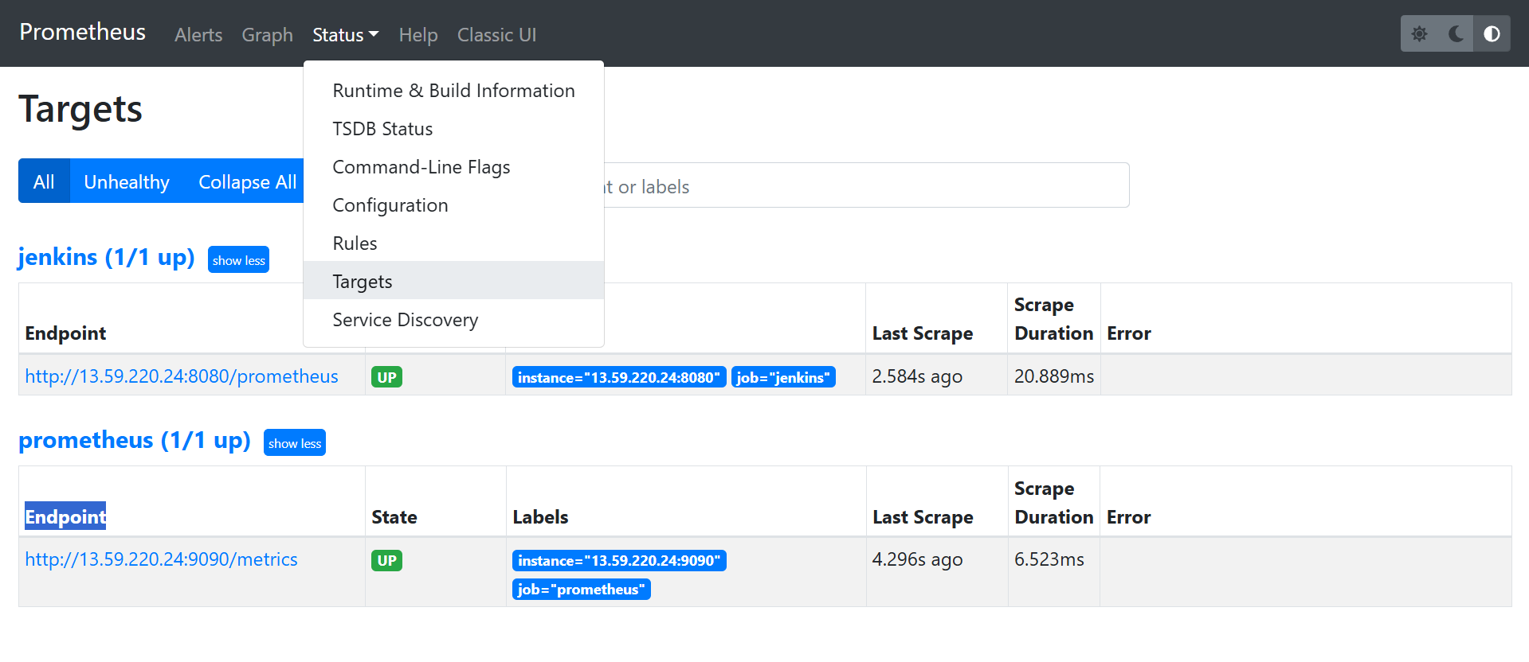

* Now connect to the Grafana by using ip of the server

Localhost(public IP):3000

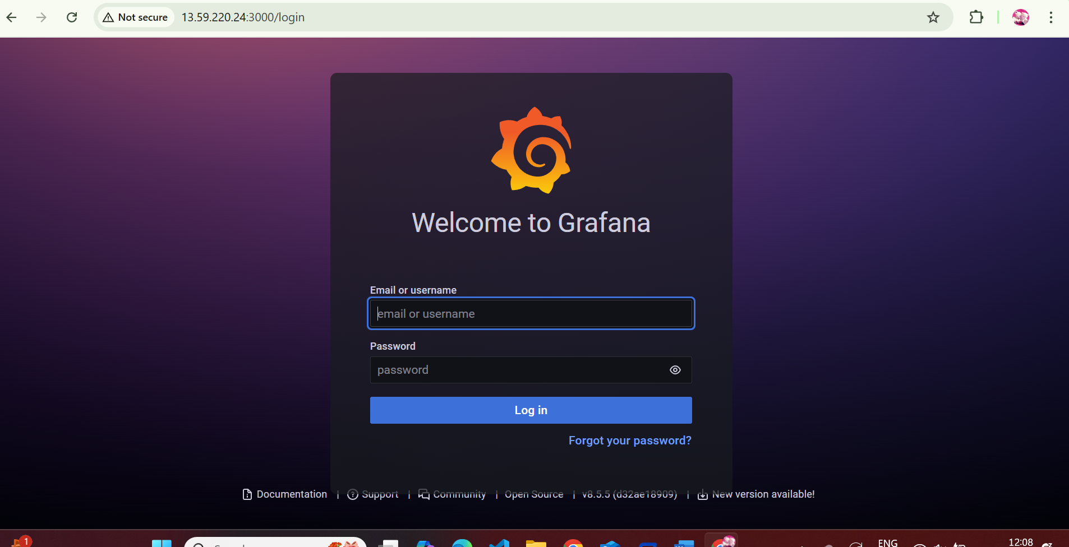

* Create user and password

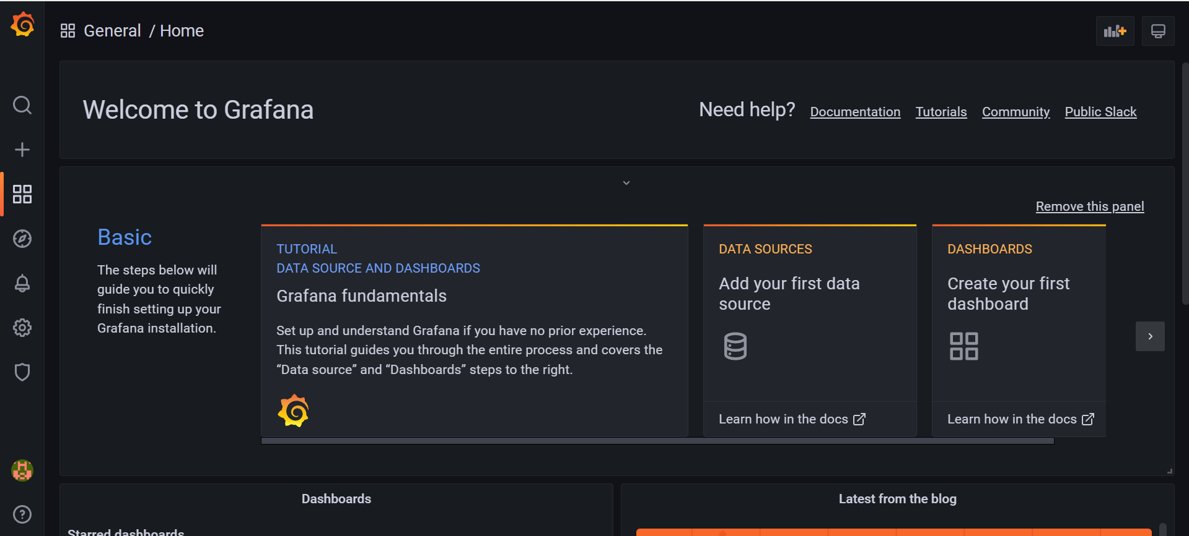

* Click on data sources
* Click on Prometheus
* Give the url of the Prometheus

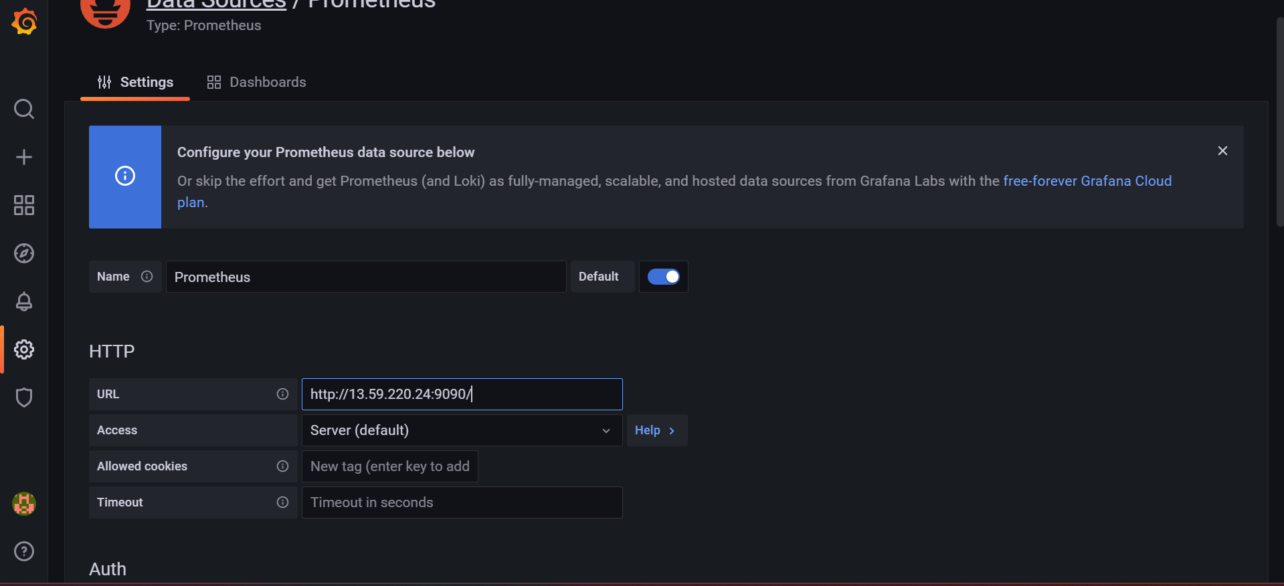

* Click on save and test
* Now go to home page and click on dashboard
* Click on add a new pannel

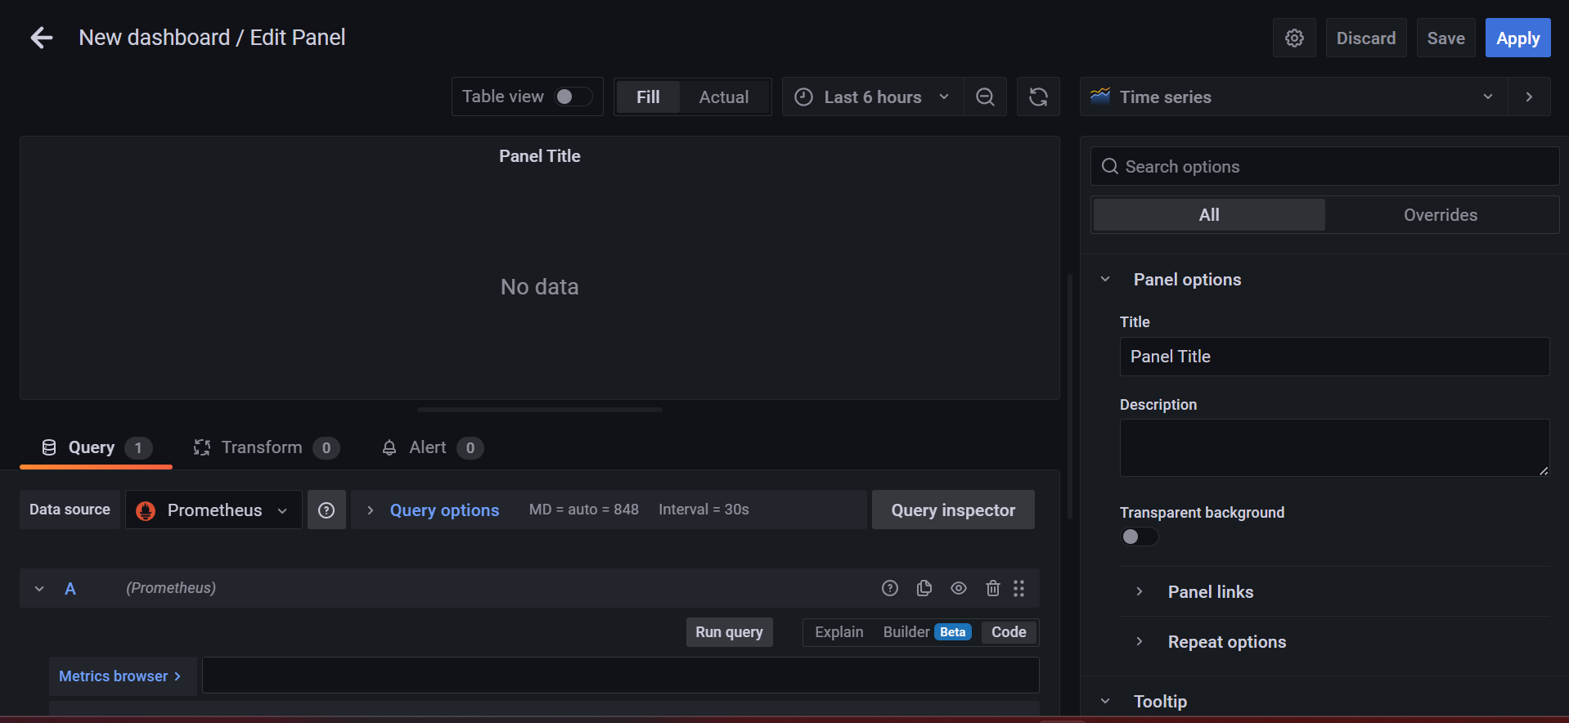

* In the metric browser we need to search the required query.
* And click on use query.

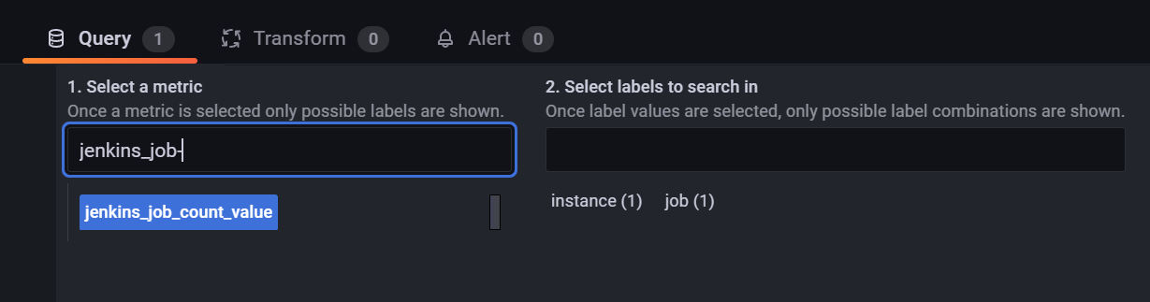

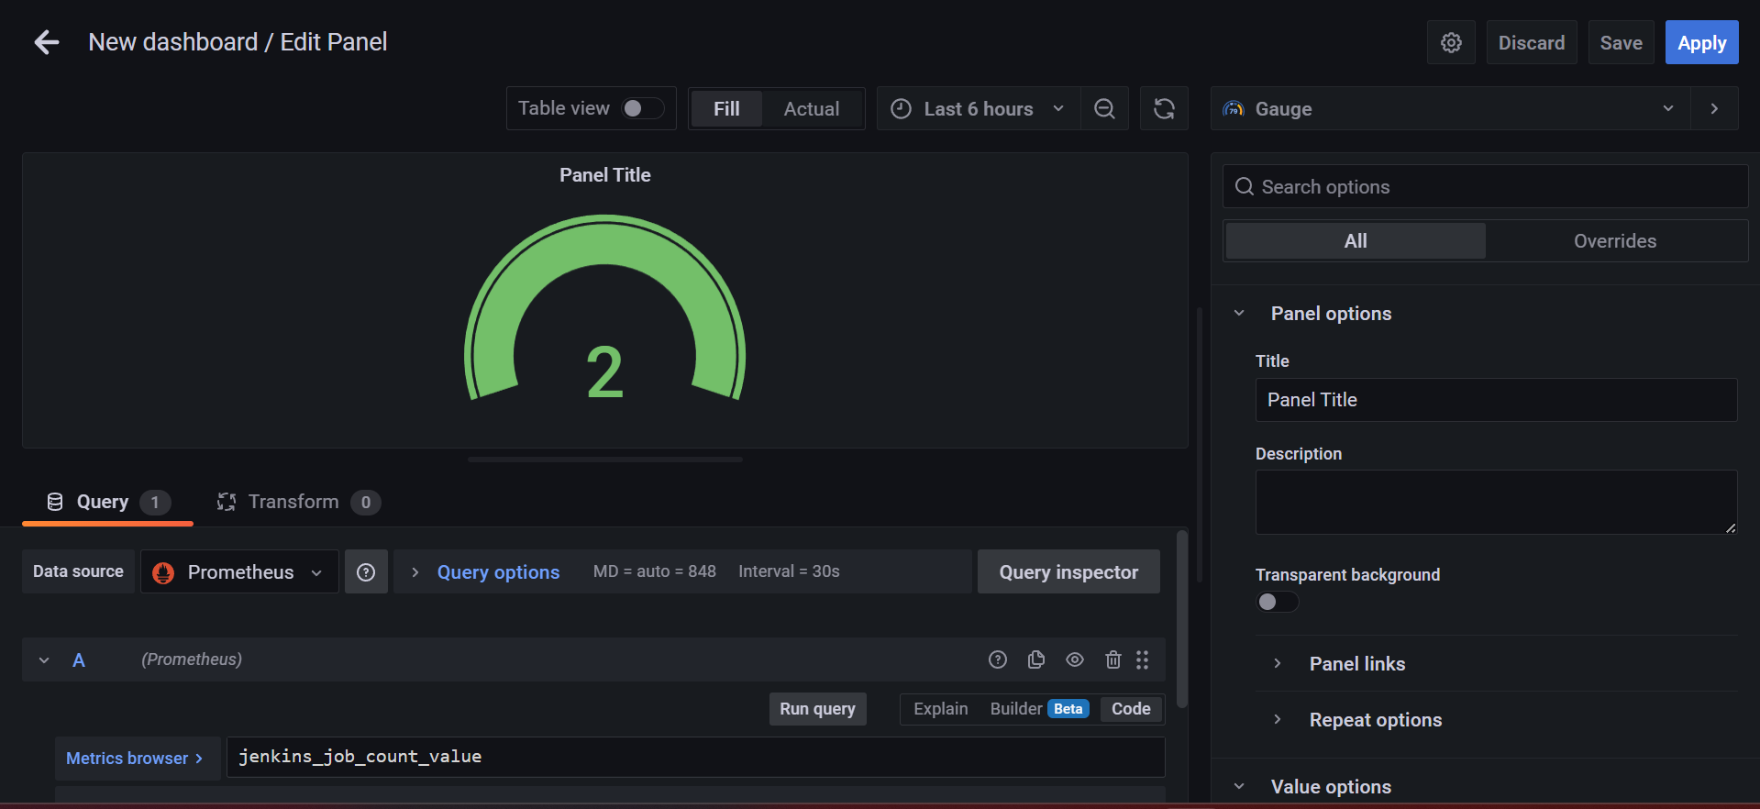

**CREATION OF EMAIL ALERT RULE FOR JENKINS**

* Now go to the dashboard and click on + symbol and click on folder

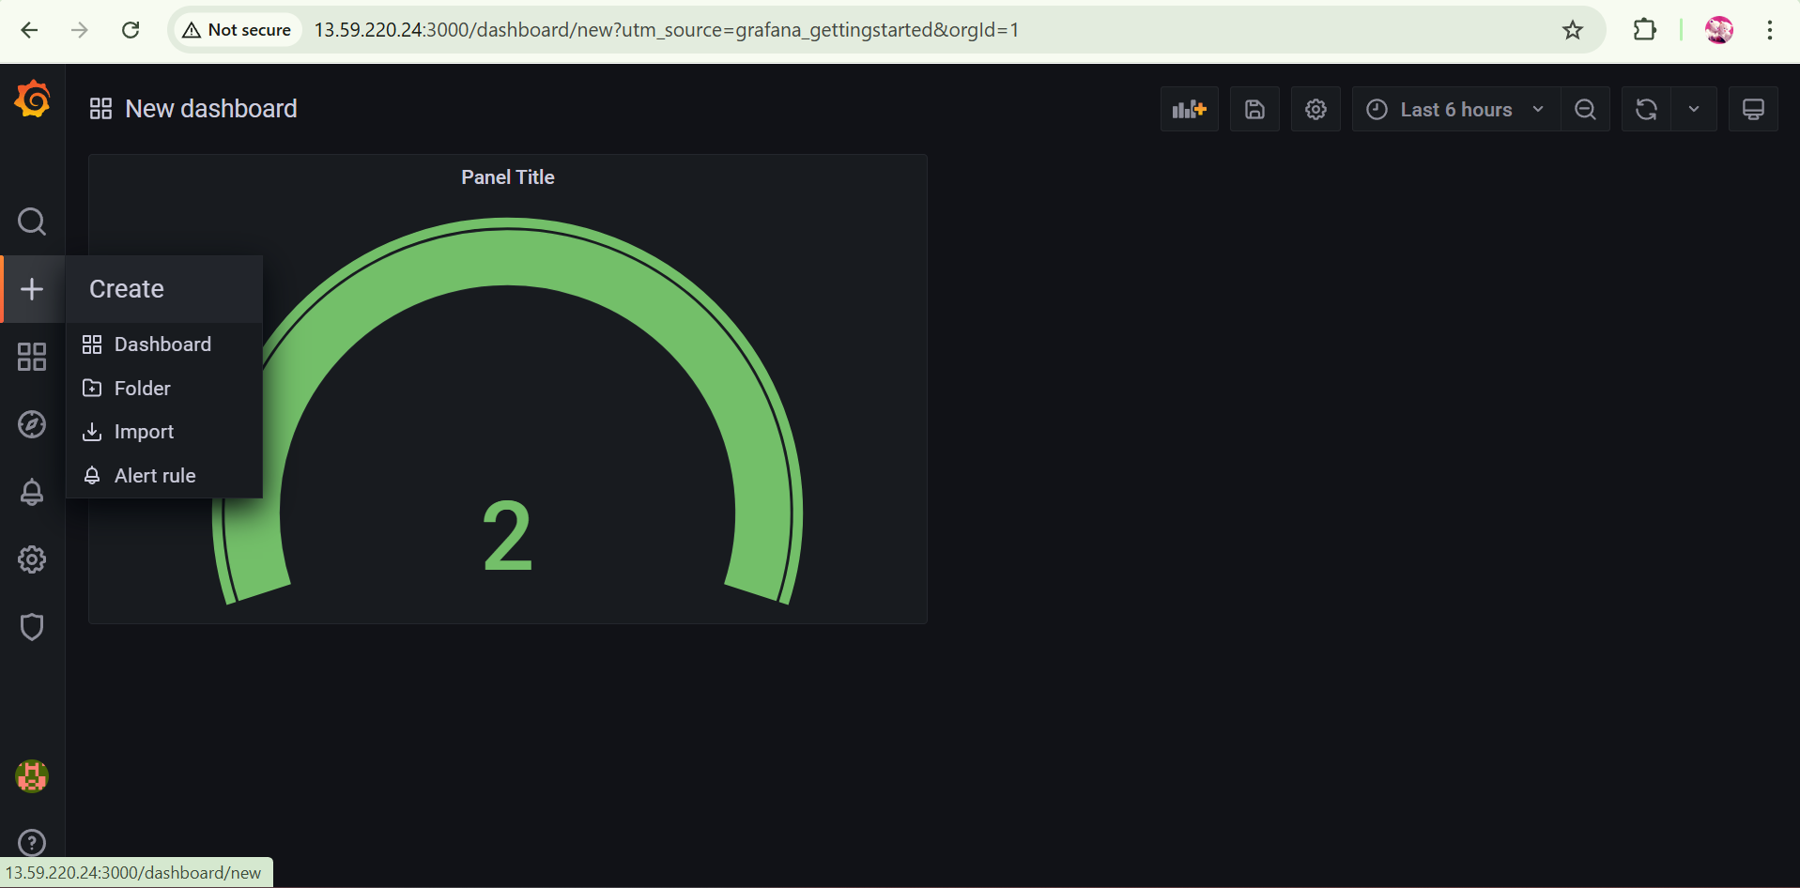

* Give a name to the folder and click on create.

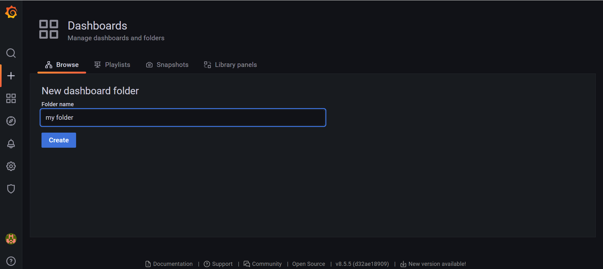

* Click on alerting rules and create the alert rule

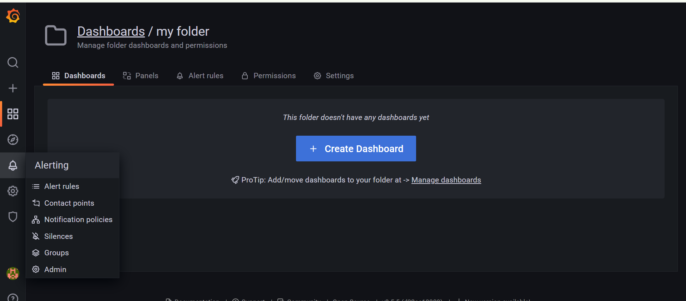

* Click on new alert rule
* Give a role name
* Store the rule in created folder and create a group

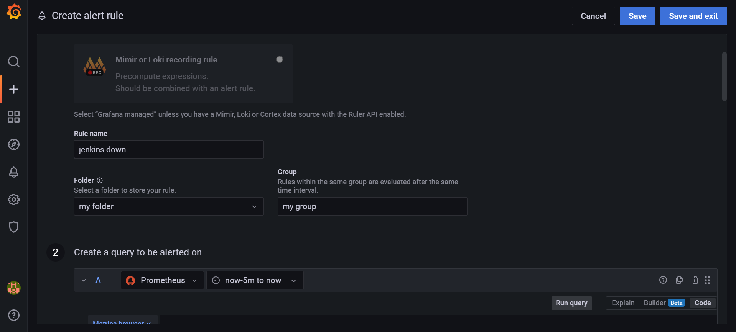

* Search your query in metric browser
* Select your reqired query and click on use query

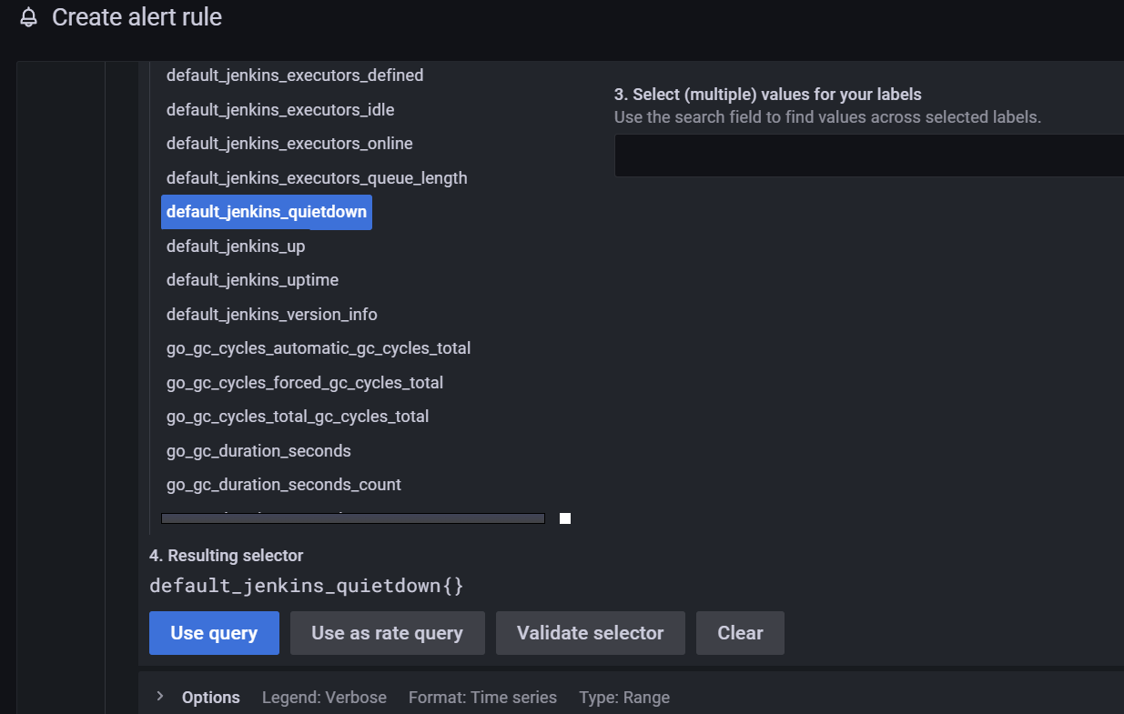

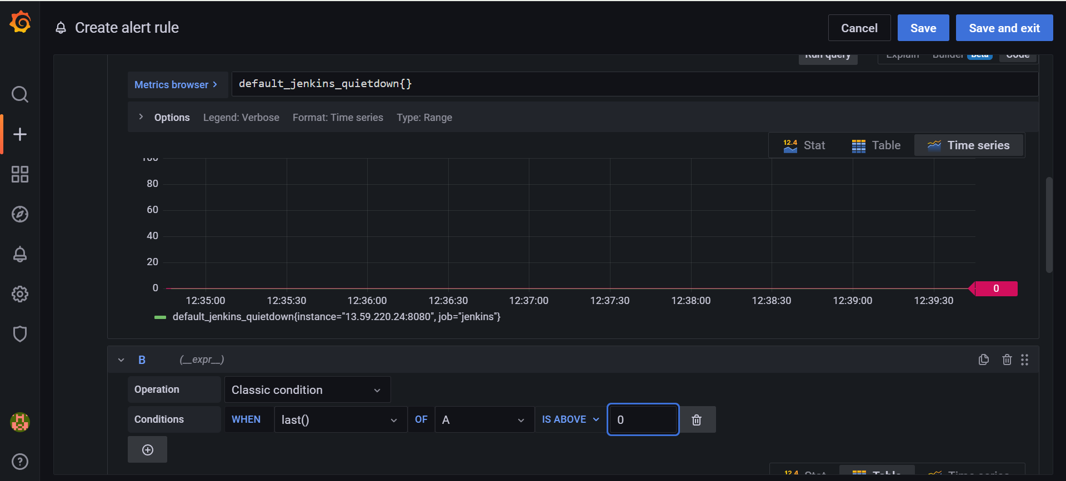

* Define your alert conditions
* And click on save.

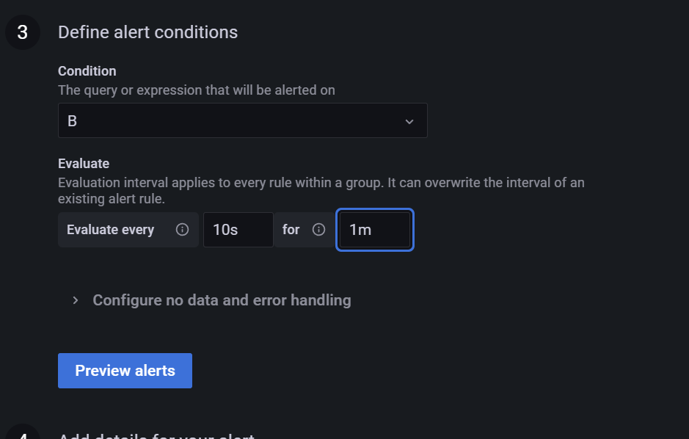

* If the Jenkins server will down we will get email notification

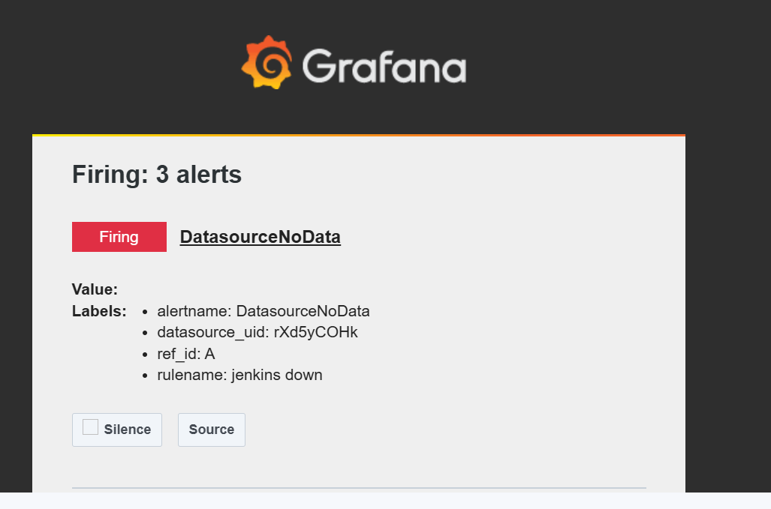

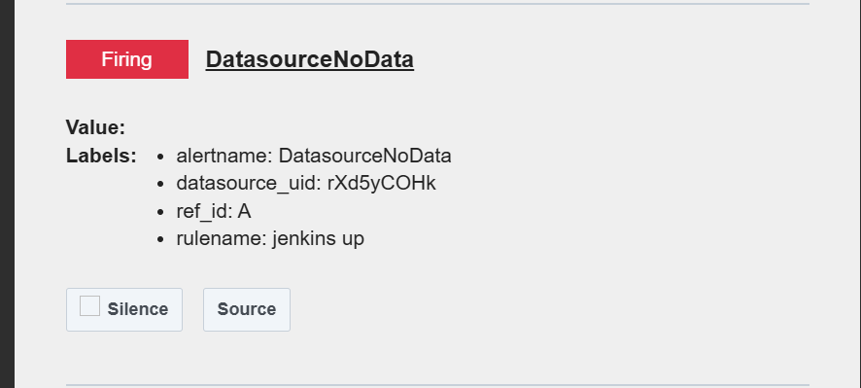

**INSTALATION AND CONFIGURATION OF NODE EXPORTER FOR CPU UTILIZATION**

* Install the node exporter using following command

**docker run -d --name=node-exporter \ --restart=unless-stopped \ -p 9100:9100 \ quay.io/prometheus/node-exporter:latest**

* Configure the Prometheus file add the fallowing details

**nano /home/ubuntu/prometheus/prometheus.yml**

**# Scrape Node Exporter metrics**

**- job_name: 'node-exporter'**

**static_configs:**

**- targets: ['public ip:9100']**

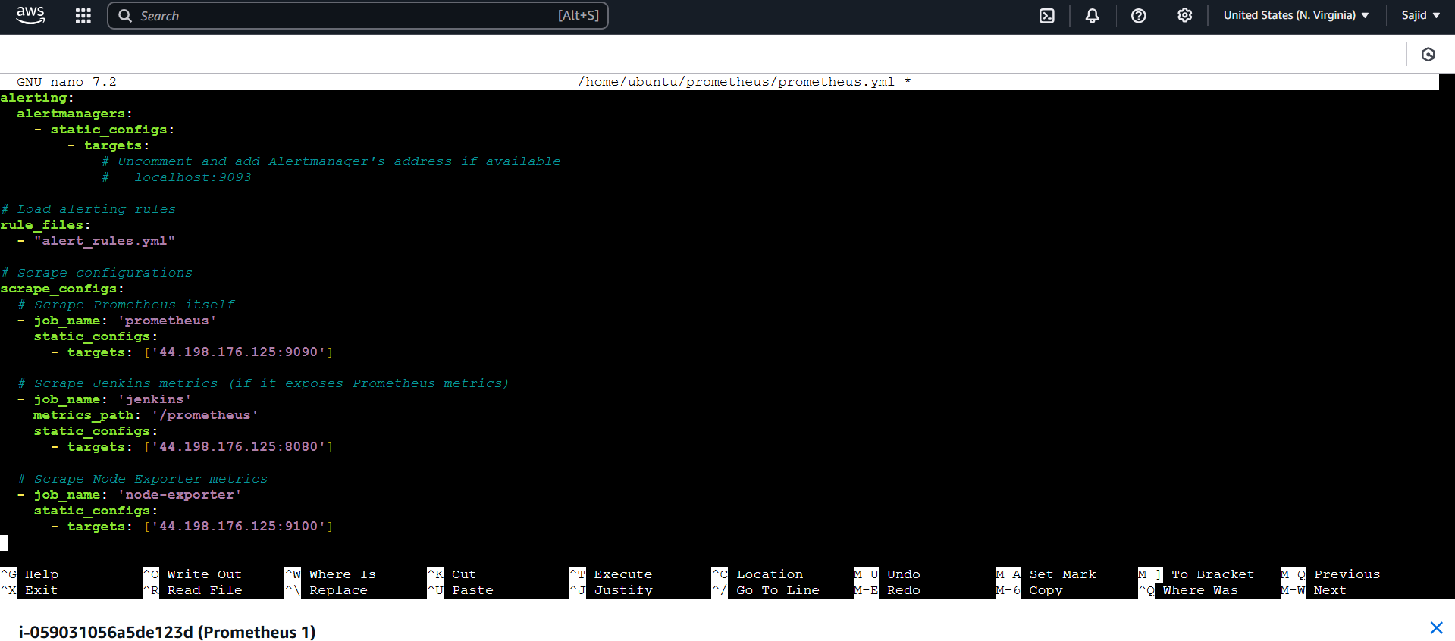

* Save and quit the file
* Add the 9100 port in security group of instance
* Restart the Prometheus

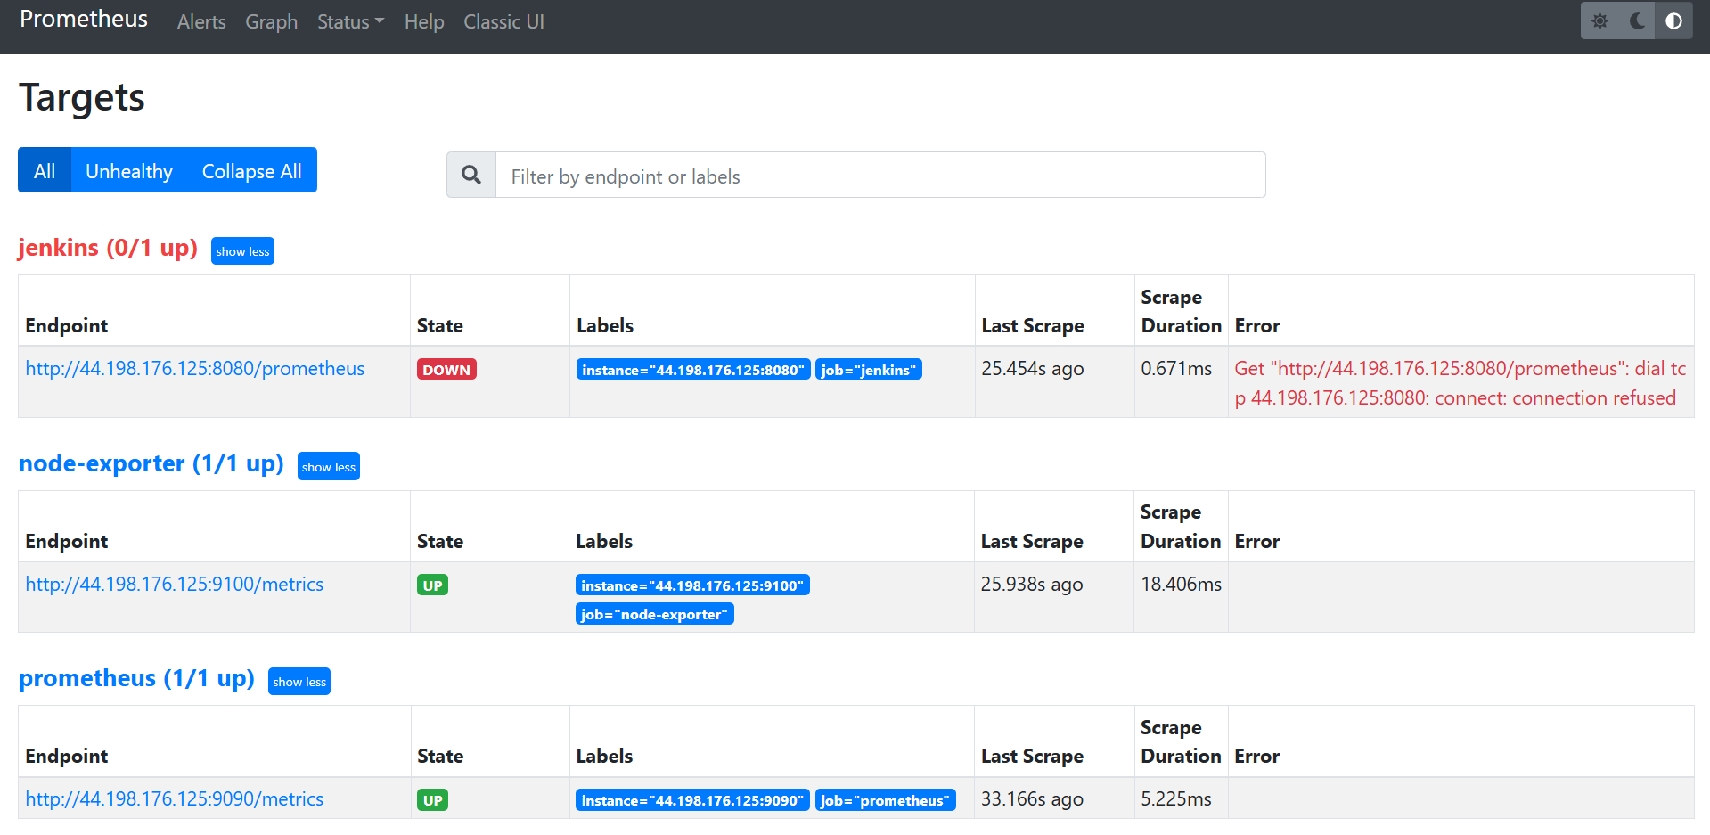

* Go to the Grafana dashboard
* And browse the metrics to know the cpu utilization

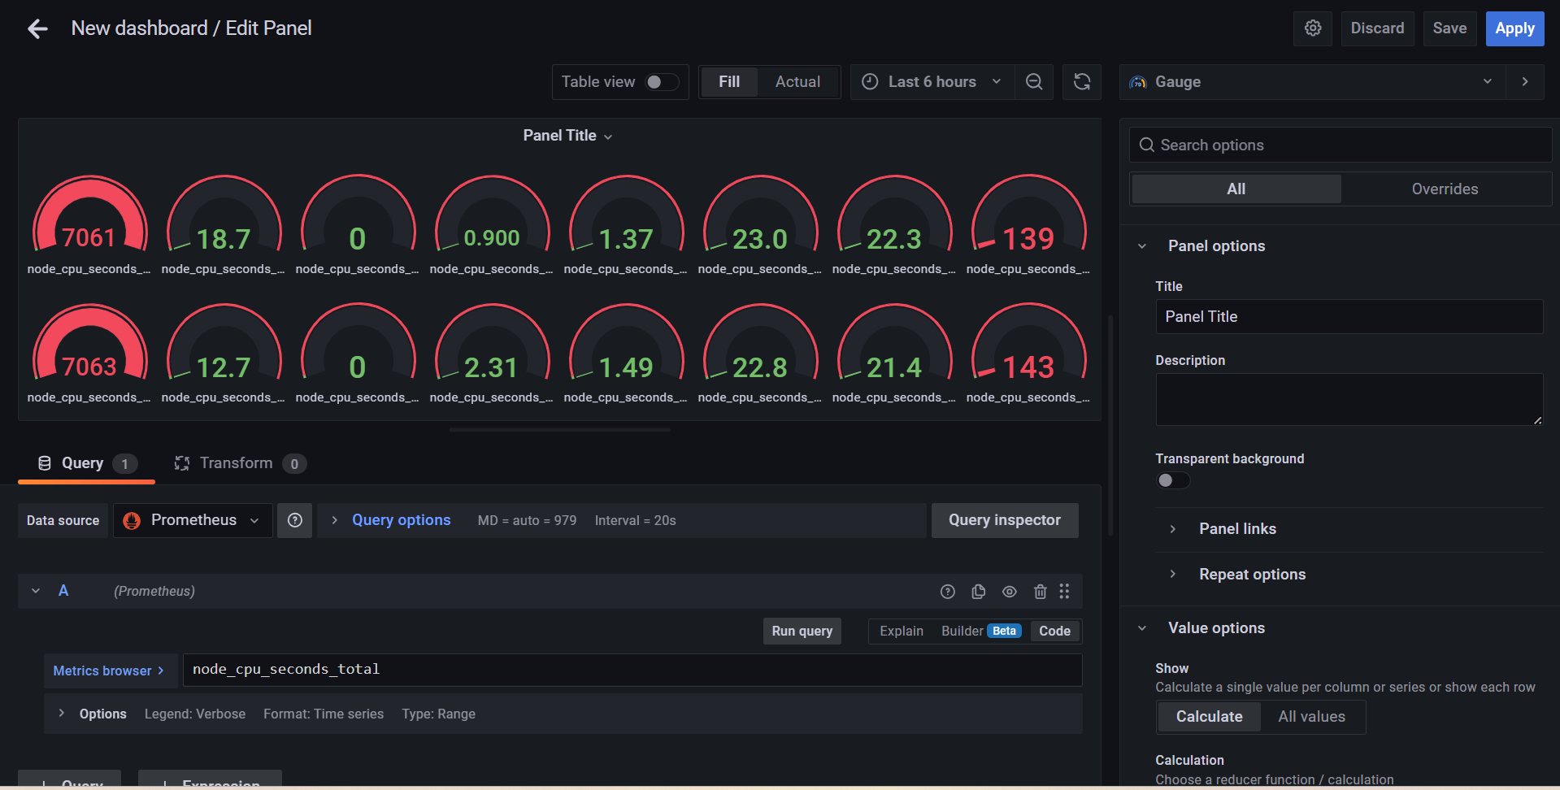

* If we need to import a dashboard click on import and specify the id and click on load

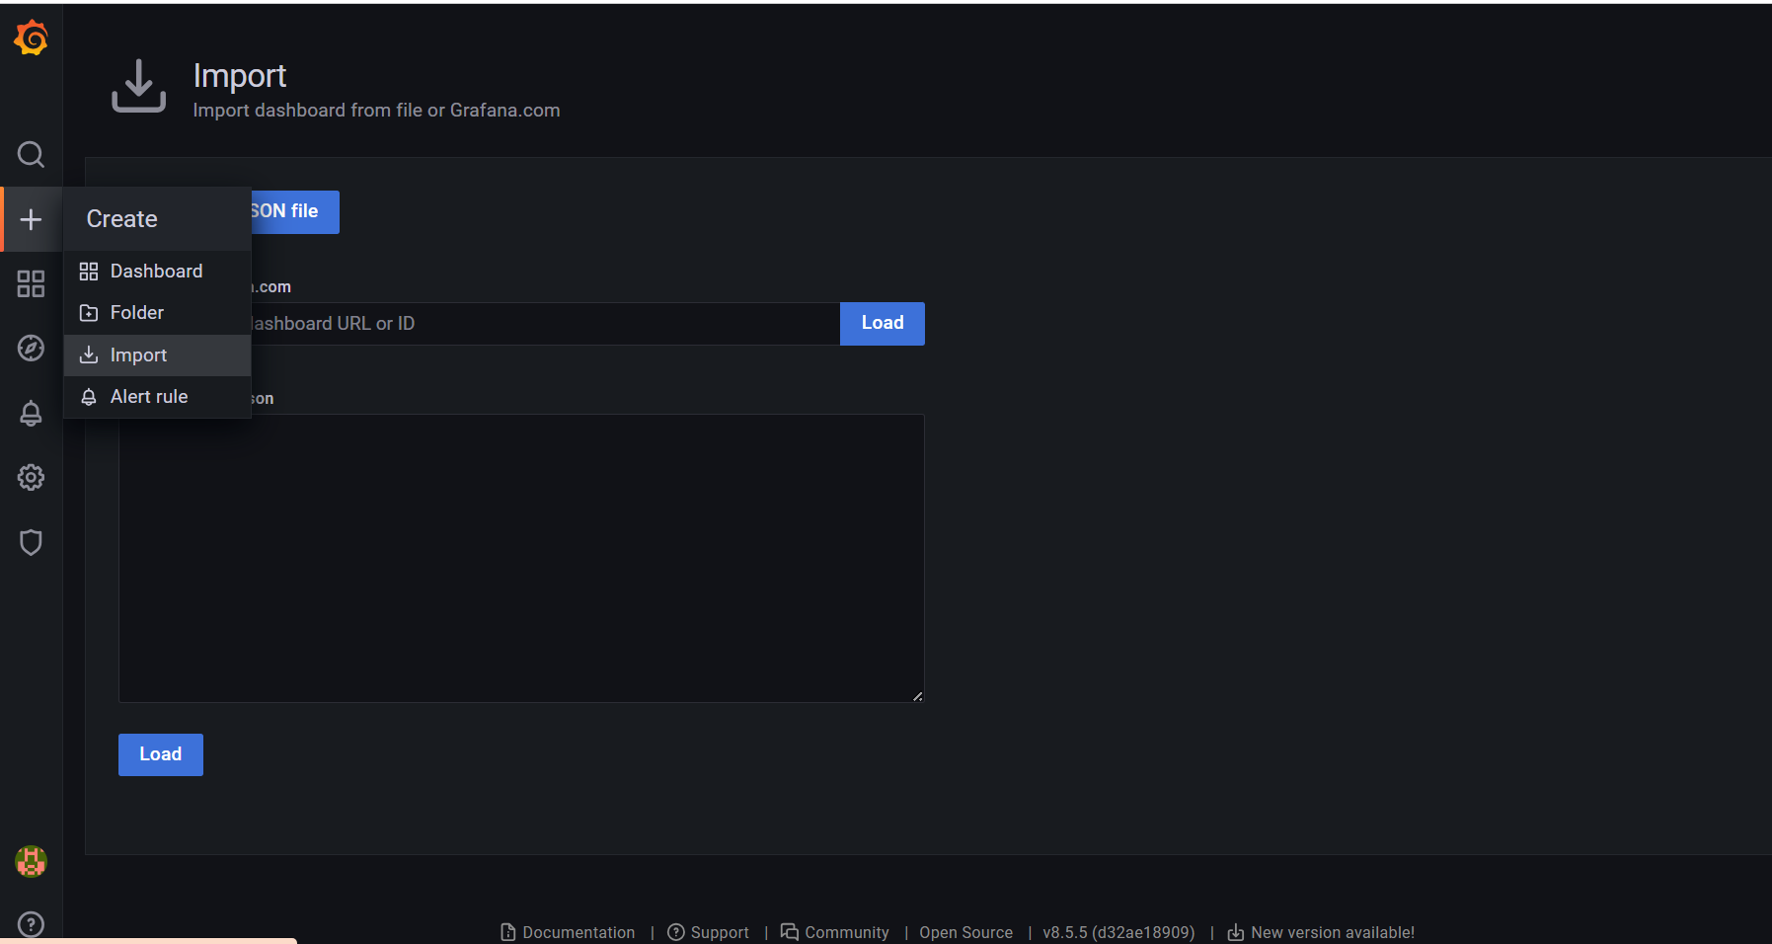

* Eg : 11074 (if we specify this id we get dashboard as below)

